EXPT 2 Simulation and Performance Evaluation of People–Process–Data–Things IoE Framework using Edge/Fog-to-Cloud Pipeline

Objective:
- To simulate the People–Process–Data–Things IoE framework using Python.
- To calculate transmission delay at different data rates.
- To evaluate end-to-end delay in Edge, Fog, and Cloud computing.
- To compare the performance of Edge, Fog, and Cloud based on time delay.
- To plot a graph of data rate versus end-to-end time delay.
Procedure :
- Open Google Colab in the browser and create a new notebook.
- Import the required libraries, NumPy and Matplotlib.
- Define the packet size and generate data rates ranging from 0.5 Mbps to 20 Mbps.
- Calculate the transmission delay using the standard formula.
- Define the propagation, processing, and queueing delays for Edge, Fog, and Cloud computing.
- Calculate the total end-to-end delay for all three computing environments.
- Print the calculated delay values for Edge, Fog, and Cloud.
- Plot the graph of data rate versus end-to-end time delay using Matplotlib.
- Execute the code by clicking the Run button in Google Colab.
10. Observe the output values and graph to compare the performance of Edge, Fog, and Cloud computing.

Program :
import numpy as np
import matplotlib.pyplot as plt
# Simulation parameters
packet_size = 1500 * 8 # 1500 bytes converted to bits
# Data rate in Mbps
data_rate = np.linspace(0.5, 20, 100)
# Standard transmission delay formula
# Delay (ms) = Packet size (bits) / Data rate (bits/s) * 1000
transmission_delay = packet_size / (data_rate * 1e6) * 1000
# Illustrative fixed delay components in milliseconds
# These values are assumptions for simulation, not universal constants
data_source=1
# Edge
edge_propagation = 1*data_source
edge_processing = 2*data_source
edge_queueing = 0.5*data_source
# Fog
fog_propagation = 5*data_source
fog_processing = 4*data_source
fog_queueing = 1.5*data_source
# Cloud
cloud_propagation = 20*data_source
cloud_processing = 8*data_source
cloud_queueing = 3*data_source

# Total end-to-end delay
edge_delay = (
transmission_delay + edge_propagation
+ edge_processing + edge_queueing
)
print(edge_delay[50])
fog_delay = (
transmission_delay + fog_propagation
+ fog_processing + fog_queueing
)
print(fog_delay[50])
cloud_delay = (
transmission_delay + cloud_propagation
+ cloud_processing + cloud_queueing
)
print(cloud_delay[50])
# Plot results
plt.figure(figsize=(9, 5))
plt.plot(data_rate, edge_delay, label="Edge")
plt.plot(data_rate, fog_delay, label="Fog")
plt.plot(data_rate, cloud_delay, label="Cloud")
plt.xlabel("Data Rate (Mbps)")
plt.ylabel("End-to-End Time Delay (ms)")
plt.title("IoE Framework: Time Delay vs Data Rate")
plt.grid(True)
plt.legend()
plt.tight_layout()
plt.show()
Output:
Data_Source =1
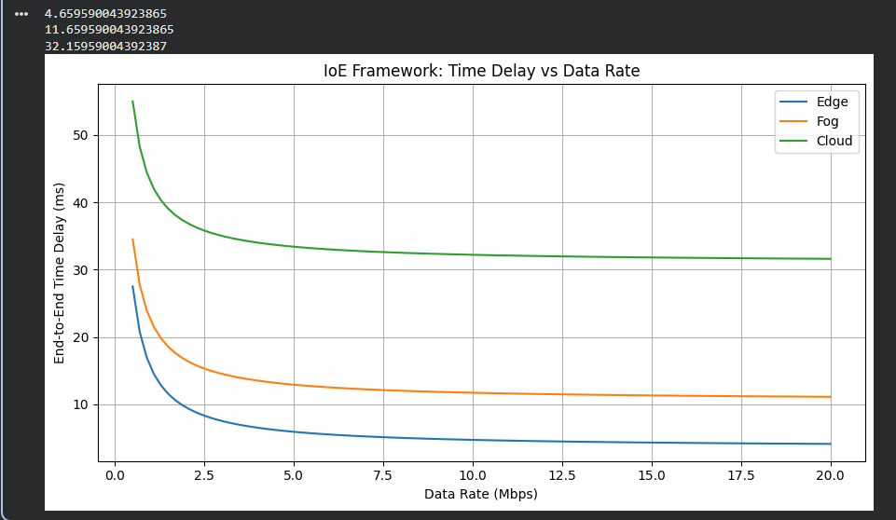
Data_Source =157
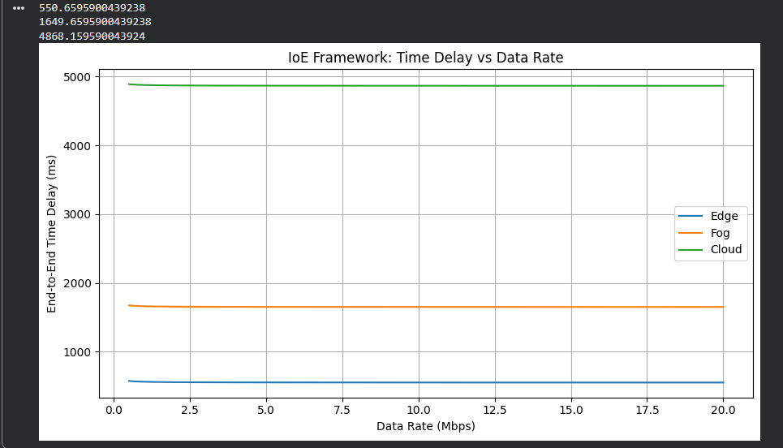

 |  | Number of Data Source
 |  | 1 | 25 | 90 | 157
EDGE | Processing Delay | 2ms | 50ms | 180ms | 314ms
EDGE | Propagation Delay | 1ms | 25ms | 90ms | 157ms
EDGE | Queueing Delay | 0.5ms | 12.5ms | 45ms | 78.5ms
EDGE | End to End Delay | 4.65ms | 88.65ms | 316.15ms | 550.65ms
FOG | Processing Delay | 4ms | 100ms | 360ms | 628ms
FOG | Propagation Delay | 5ms | 125ms | 450ms | 785ms
FOG | Queueing Delay | 1.5ms | 37.5ms | 135ms | 235.5ms
FOG | End to End Delay | 11.65ms | 263.65ms | 946.15ms | 1649.65ms
CLOUD | Processing Delay | 8ms | 200ms | 720ms | 1256ms
CLOUD | Propagation Delay | 20ms | 500ms | 1800ms | 3140ms
CLOUD | Queueing Delay | 3ms | 75ms | 270ms | 471ms
CLOUD | End to End Delay | 32.15ms | 776.15ms | 2791.15ms | 4868.15ms
Table:

Result:
The People–Process–Data–Things IoE framework was successfully simulated using Python in Google Colab. The end-to-end time delay for Edge, Fog, and Cloud computing was calculated and plotted against different data rates. The graph shows that Edge computing has the lowest delay, followed by Fog and Cloud computing, based on the assumed delay parameters.

